**Global Oil and Energy Dynamics:**

**: India, Russia, and Geopolitical Impacts (2016–2025)**

“A Data-Driven Analysis of Energy Trade, Oil Prices, Trends, Shifts, and Market Impacts

*Author – Mohit Chaturvedi, 29–Sept 2025*



## ****Table of Contents****

1. Executive Summary & Research Questions
2. Methodology
3. Tools & Technologies
4. Data Sources
5. Key Insights
6. Research Questions

## ****1. Executive Summary & Research Questions****

### ****1.1 Problem Statement****

From 2016 to 2025, geopolitical events like the Russia–Ukraine war and OPEC+ production cuts, coupled with India and China’s increased reliance on discounted Russian oil and U.S./EU sanctions, drove sharp fluctuations in global oil prices and trade patterns. These dynamics disrupted energy markets, heightened inflation, and posed challenges for policymakers and industries navigating energy security and economic stability

### ****1.2 Purpose of the Report****

* Identify correlations between oil prices, inflation, and shifting trade patterns
* Assess the economic impact of Russia’s oil exports on India and China
* Analyse how U.S. energy exports to Europe and Russian discounts to Asia reshaped global trade and profits
* **Highlight sanction loopholes and indirect trade flows (e.g., uranium, fertilizers, Indian diesel refined from Russian crude) to illustrate the limits of geopolitical restrictions**

## ****2. Methodology****

* Data cleaning & standardization (units, currencies, missing values)
* Trend analysis of oil prices, imports, exports, and energy types
* Correlation assessment: oil prices, inflation, and trade flows
* Visualization using charts, tables, and dashboards

## ****3. Tools & Technologies****

Python | Power BI | Excel | ChatGPT | GROK

## ****4. Data Sources****

EIA | IEA | IMF | World Bank | CEIC | PPAC India | CREA | Statista | Trading Economics | ExxonMobil | Chevron | Reuters

## ****5. Key Insights****

* **Sanctions' Limited Impact:** U.S./EU sanctions had a muted effect as Russia pivoted to Asia and established alternative trade channels.
* **Importer Benefits:** India and China’s purchases of discounted Russian oil stabilized domestic energy costs.
* **Oil-Inflation Link:** Strong positive correlation (r = 0.87) between global oil prices and inflation highlights energy’s role in price stability.
* **Profit Over Ethics:** Global energy flows are profit-driven; for example, Ukraine imports diesel from Indian refineries using Russian crude.
* **Trade Driven by Necessity:** Markets prioritize economic and operational considerations over political or moral arguments.

## ****6. Research Questions****

1. **Economic & Price Impact:** Did increased Russian oil purchases benefit India & China and stabilize global prices?
2. **Geopolitical Implications:** How effective are sanctions when alternative buyers and complex trade routes exist?
3. **Market Morality:** Does the reality of global trade—where even nations in conflict prioritize cost—challenge the moral framing of energy sanctions?

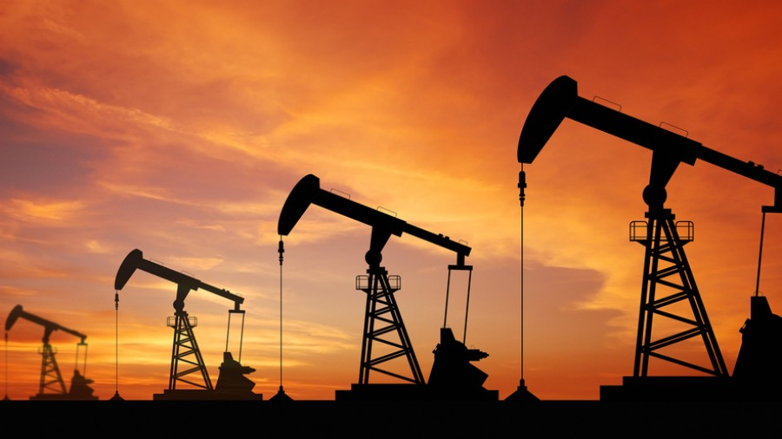

**Section -1 Global Oil Price and Inflation Rate**

**1.1 Crude Oil Price Comparison**

“This chart compares the annual average crude oil prices of the global Crude Oil Price and the USA Crude Oil Type Price from 2016 to 2025. It highlights how global events such as the COVID-19 pandemic and the Russia–Ukraine (2022) war impacted oil prices worldwide.

**Figure 1:** Global vs. USA Crude Oil Prices (clustered columns), 2016–2025. Event markers highlight COVID-19 (2020) and Russia–Ukraine War (2022).

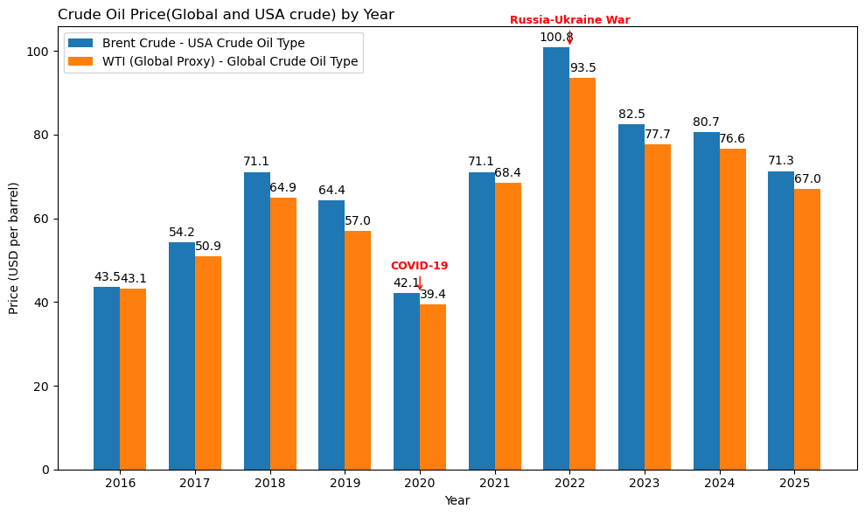

### ****Key Insights & Trends****

• “Global and US crude prices follow a similar trend, though the US Crude oil Prices are High Due to Extraction Cost is High(50 -60$ per Barrel).”

• “Prices dipped sharply in 2020 during COVID-19, followed by a steep rebound in 2022 due to geopolitical tensions.”• “Event markers clearly indicate how global crises and Events influence crude prices.”

**1.2 Impact of Global Oil Prices on Inflation (2016–2025)**

This subsection analyses the relationship between **global oil prices** and the **global inflation rate** over the period 2016–2025. Oil is a critical input for the global economy, and fluctuations in its price have direct and indirect effects on the cost of goods and services. By examining this period, we can understand how major events, such as the **COVID-19 pandemic** and the **Russia–Ukraine war**, have influenced both energy markets and inflation globally.

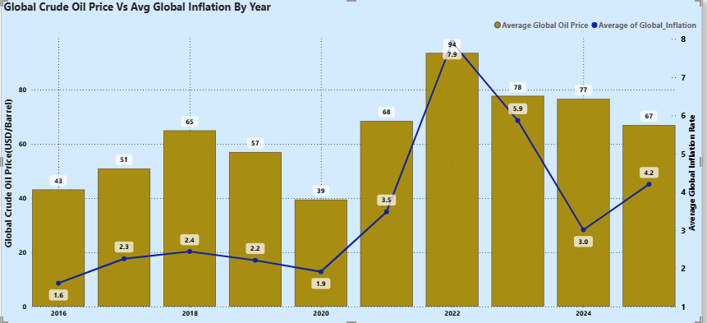

**Figure 2:** Global Oil Prices (columns) vs Global Inflation Rate (line), 2016–2025. Event markers highlight COVID-19 (2020) and Russia–Ukraine War (2022).

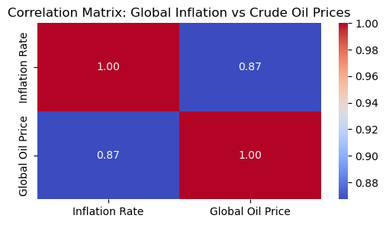

**Figure 3:** Correlation matrix showing the relationship between Global Oil Prices and Global Inflation Rate (2016–2025). The correlation coefficient is 0.87, indicating a strong positive relationship.

### ****Key Insights & Trends****

• **COVID-19 impact (2020):** Global oil prices dropped sharply during the pandemic due to reduced demand, leading to subdued inflationary pressures worldwide.

• **Russia–Ukraine war (2022):** Oil prices surged significantly, driving a spike in global inflation rates, illustrating the sensitivity of inflation to energy costs.

• **Overall correlation:** There is a strong positive correlation (**r = 0.87**) between global oil prices and global inflation, indicating that oil price movements are a major driver of global inflation.

• **Trend pattern:** Periods of relative oil price stability (2016–2019, 2023–2025) correspond to moderate and stable inflation trends, while shocks in 2020 and 2022 align with sharp inflation fluctuations.

**Section 2: India and China Oil Imports (2016–2024)**

**2.1 India Oil Imports**

India is one of the world’s largest crude oil importers, heavily dependent on international suppliers to meet its energy needs. Between 2016 and 2024, India’s oil imports were influenced by global price shocks, domestic demand cycles, and shifting trade partnerships.

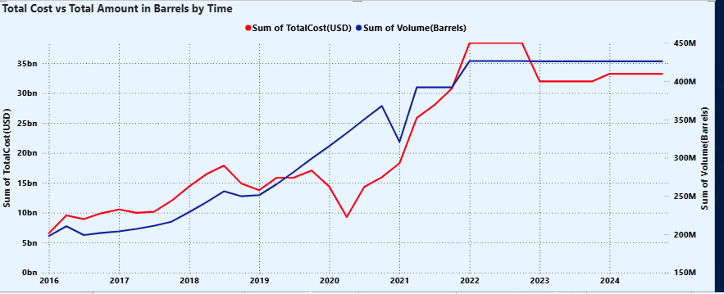

Figure 4: India’s Oil Import Cost (USD) vs. Quantity (Million Barrels), 2016–2024. COVID-19 (2020) lowered costs, while the Russia–Ukraine War (2022) drove prices to ~$113/barrel. Note: 2025 data is partial (till August).

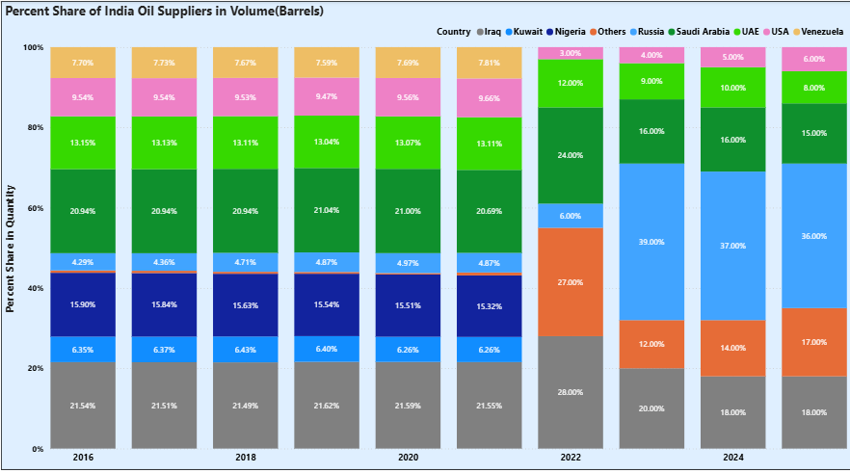

Figure 5: India’s Oil Importer Share (%), 2016–2024. Saudi Arabia was the leading supplier until 2021, after which discounted Russian oil boosted Russia’s share to ~37% in 2024, making it India’s top supplier.

### ****Key Insights & Trends****

* **COVID-19 (2020):** Global demand collapsed, lowering crude prices (~$20–30/barrel) and allowing India to import more oil at reduced cost.
* **Russia–Ukraine War (2022):** Crude prices spiked to ~$113/barrel, sharply increasing import costs, while import quantities remained relatively stable.
* **Post-2022 (Russian Discounts):** Russia offered discounted oil, which helped **reduce India’s import costs** while maintaining or slightly increasing import volumes.
* **Supplier Shift:** Saudi Arabia, UAE and IRAQ were India’s top suppliers until 2021; post-discounts, **Russia’s share rose to ~37% in 2024**, making it India’s largest supplier.
* **Overall Trend:** India’s oil imports have become highly **price-sensitive**, with global events and supplier dynamics directly affecting both **costs and import volumes**.

**2.1 China Oil Imports**

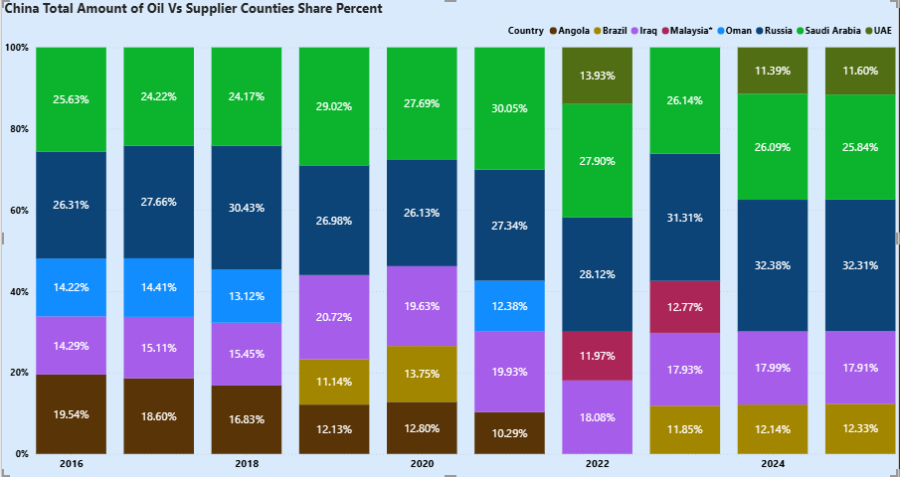

Figure 6: China’s Oil Importer Share (%), 2016–2025.

### ****Key Insights – China****

* Russia was already a supplier (~25%) from 2016–2021; Saudi Arabia was the top supplier during this period, but with discounted oil, Russia’s share rose to ~32% by 2024, overtaking Saudi Arabia.
* Other energy sources like LNG and pipeline gas also play a significant role in China’s imports (discussed later).

### ****Final Insights – India & China Oil Imports****

Both India and China have increased their reliance on Russian oil in recent years. India’s imports benefited from post-2022 Russian discounts, reducing costs and maintaining volumes, with Russia reaching ~37% share in 2024. China’s imports show a gradual rise in Russia’s share from ~25% (2016–2021) to ~32% in 2024, overtaking Saudi Arabia. Overall, geopolitical events, price fluctuations, and supplier dynamics have significantly shaped oil import patterns for both countries, while LNG and pipeline gas remain important for China’s energy mix.

**Section 3: Russia Energy Exports (2016–2025)**

## ****Overview / Context****

Russia is one of the world’s largest energy exporters, supplying crude oil, LNG, natural gas (pipeline and LNG), and coal to global markets. Its energy exports have been shaped by:

* **Global demand fluctuations** (e.g., COVID-19 impact)
* **Geopolitical events** (e.g., sanctions, Russia–Ukraine war)
* **Discounts and trade offers to key importers** (e.g., India and China)

This section examines Russia’s export patterns by **country groups and energy type** over 2016–2025.

Figure 7: Russia’s Total Energy Export Value (USD Billion), 2016–2025.

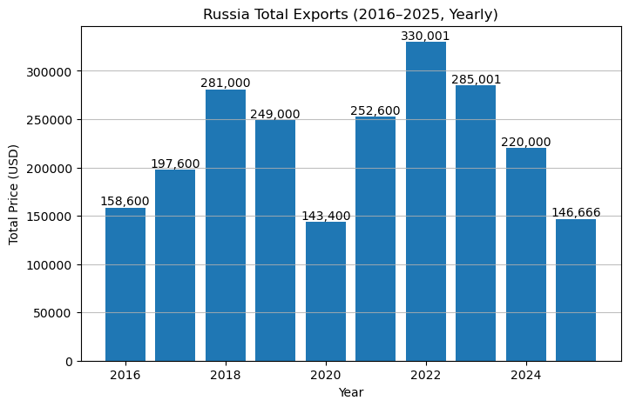

### ****Key Insights – Russia Total Energy Exports****

* **2016–2019:** Steady growth in export revenue from oil, gas, and coal.
* **2020 (COVID-19):** Global demand collapse caused a temporary dip.
* **2021–2022:** Post-COVID recovery and geopolitical tensions drove energy prices up.
* **Post-2022:** European sanctions reduced exports to the EU, but **discounted sales to India, China, and Asia** helped sustain revenue.
* **Trend:** Russia’s energy export strategy shifted **from Europe-focused to Asia-focused**, balancing sanctions impact with higher sales to emerging markets.

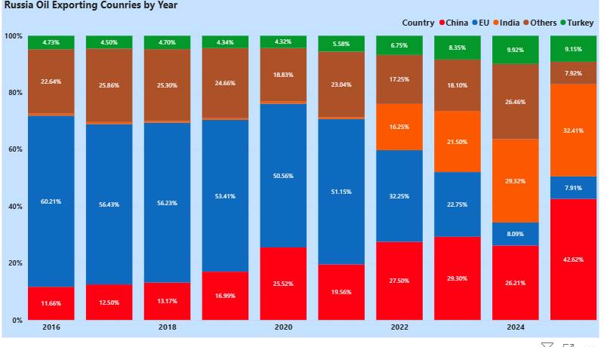

Figure 8: Russia’s Energy Exports by Country (%), 2016–2025.

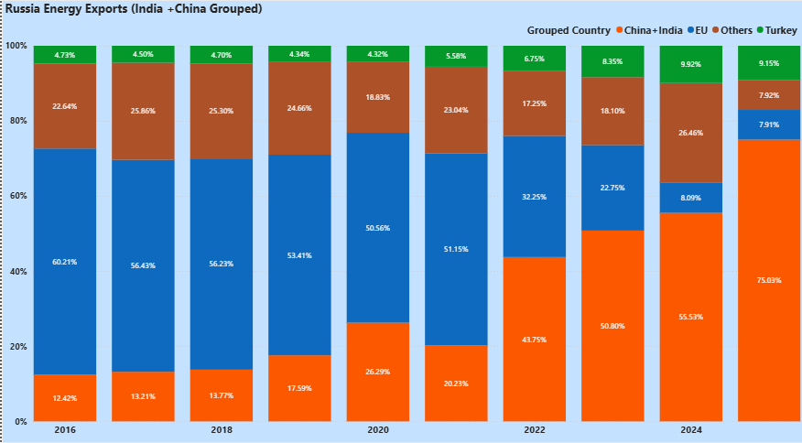

Figure 9: Russia’s Energy Exports by **Country Groups** (**India + China** ), 2016–2025.

### ****Key Insights – Russia Energy Exports****

* **Shift to Asia:** India and China have become the dominant importers, with combined share surging to 75% by 2025.
* **Europe Decline:** EU’s share fell sharply from 50% in 2021 to 8% in 2025 due to sanctions and geopolitical restrictions.
* **Individual Growth:** India increased from <3% to 32%, China from ~30% to 42% (2025 till August).
* **Overall Trend:** Russia strategically pivoted from Europe-focused exports to Asia, maintaining revenue through discounted offers to key Asian buyers.

**Russia Exports Revenue Based on Energy Type**

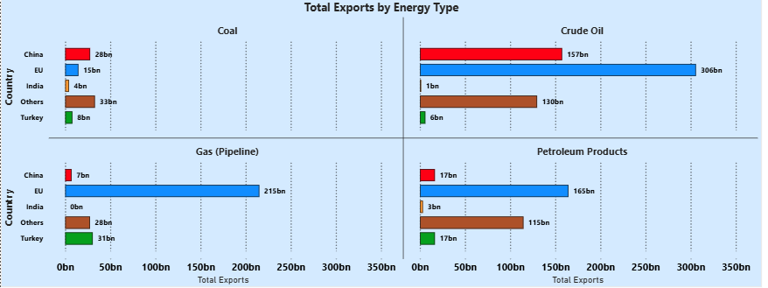

Figure 10: Russia Energy Export Revenue by Type (Crude Oil, LNG, Pipeline Gas, Coal), **2016–2021.**

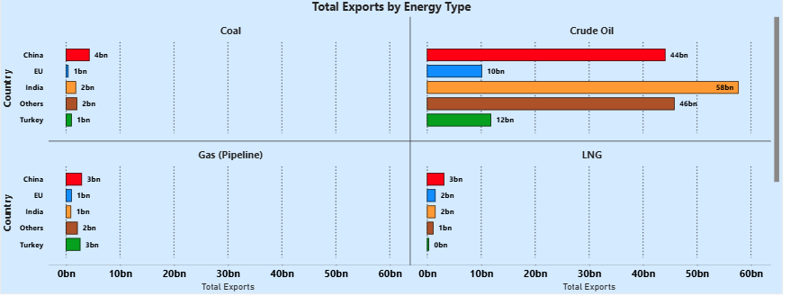

Figure 11: Russia Energy Export Revenue by Type (Crude Oil, LNG, Pipeline Gas, Coal), for **Year** **2024**.

### ****Key Insights – Export Revenue by Energy Type & Region****

* **2016–2021:** Europe dominated revenue for all energy types (oil, gas, LNG, coal).
* **2022–2025:** Asian markets, especially India and China, became the main revenue sources.
* **Crude Oil & LNG:** Major contributors to Russia’s total export revenue.
* **Overall Trend:** Russia shifted its energy export focus from Europe to Asia, maintaining overall revenue despite sanctions and geopolitical pressures.

2018: Total exports ≈ $275B

2022 (early war): Total exports ≈ $325B

2024: Total exports ≈ $220B

**Section 4: USA Energy Exports (2016–2025)**

### 4.1 Introduction

The Russia–Ukraine conflict and subsequent EU sanctions on Russian oil transformed the U.S. into Europe’s key alternative energy supplier between 2022 and 2025. U.S. crude oil, refined products, and LNG exports expanded rapidly, boosting national revenues and reshaping global trade flows. This section highlights U.S. oil export volumes, trade relations with Europe, and the performance of leading U.S. oil companies during this period.

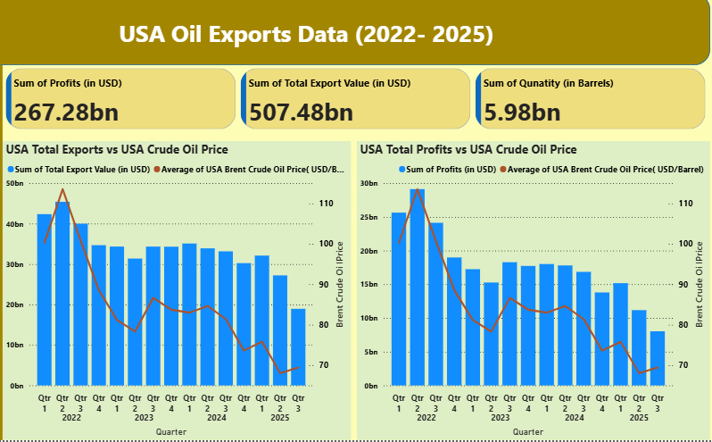

Figure 12 — U.S. Oil Exports, Company Profits, and Global Oil Price (2022–2025)

### ****Key Insights & Trends****

In 2022, U.S. oil exports and company profits soared alongside a spike in global oil prices due to the Russia–Ukraine conflict. However, as India and China began sourcing more oil from Russia, global demand for U.S. crude softened, leading to a decline in oil prices and a corresponding drop in profits through 2023–2025, even though exports remained relatively stable. But if Oil Price Continues to Drop below $60 per barrel , then US Oil Producing Industry may impact, Since Extraction cost of US Crude is 50$ - 60$ per Barrel,

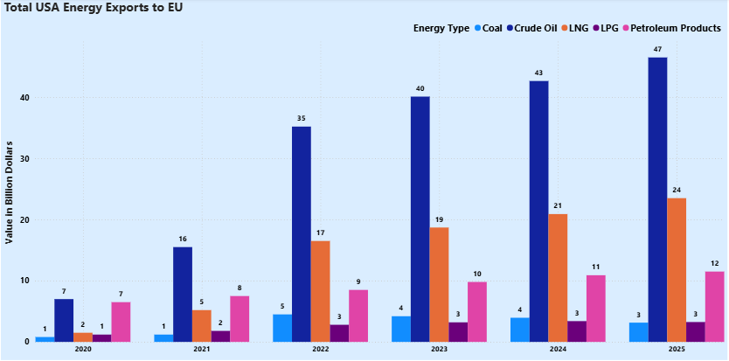

Figure 13 — Transatlantic **U.S**. Energy Exports to **European Union** (2020–2025)

### ****Key Insights & Trends****

The EU’s ban on Russian oil in 2022 triggered a dramatic surge in U.S. crude and LNG exports, turning Europe into the primary destination for American energy. While growth moderated from 2023–2025, the shift established a lasting rerouting of energy flows across the Atlantic.

Figure 14 — Net Revenue of **Top 3 U.S. Oil Companies** (Chevron, ConocoPhillips, ExxonMobil), 2022–2025

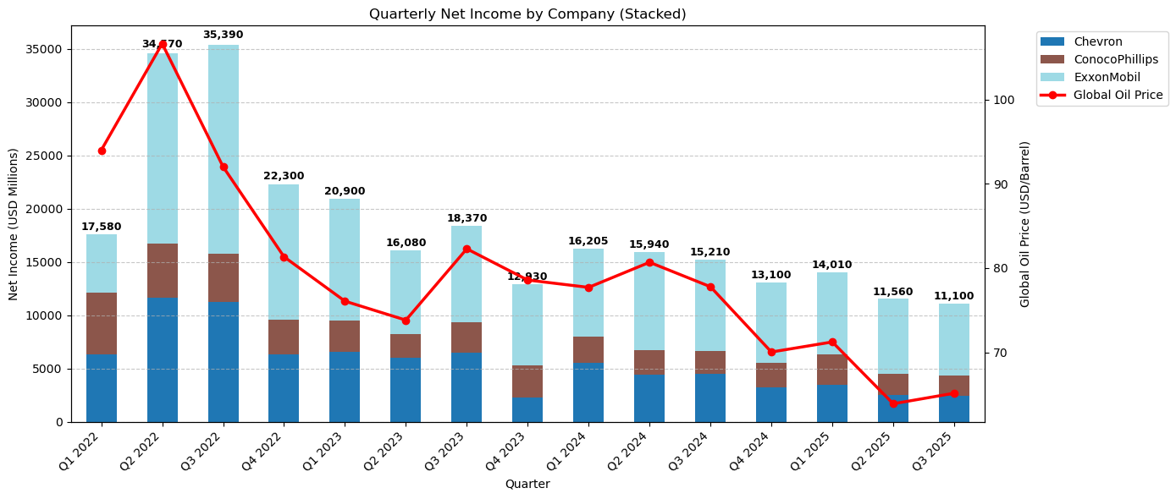

### ****Key Insights & Trends****

U.S. oil majors companies **enjoyed record revenues in 2022**, closely tracking Brent prices. With India and China ramping up Russian oil imports, global oil prices softened, causing revenues and **profits to drop in 2023–2025**, though they remained above pre-2022 levels due to continued strong export demand elsewhere.

**Section 5 — Morality and Ethics or Profit**

Despite leading global sanctions against **Russia** following the 2022 Ukraine conflict, the **United States** continues to **import** essential commodities like **uranium**, **fertilizers**, and **energy**, with imports valued at approximately **$3 billion in 2024** (Figure 16). Similarly, Ukraine, a key advocate for sanctions, emerged as a top importer of diesel refined from Russian crude in India, sourcing 18.5% of its diesel imports from India in August 2025 due to lower costs (Figure 15). These examples highlight the tension between geopolitical ethics and economic incentives, demonstrating that global energy and commodity markets prioritize profit and necessity over moral or political considerations, even amid sanctions and geopolitical pressures.

**Ukraine Diesel Imports**

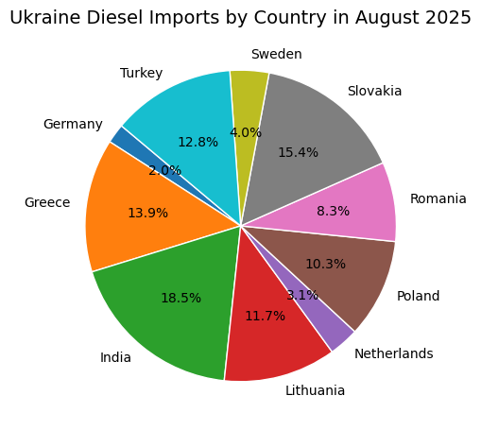

Figure 15— Ukraine’s Top Diesel Suppliers by Share, August 2025

Purchased as Refined Diesel by **Ukraine**

Purchased and Refined at **Indian** Refineries

**Russian** Crude Oil

**Insight:**  
In August 2025, Ukraine sourced **18.5% of its diesel imports from India**, making India the single largest supplier. Notably, much of this diesel was refined from **Russian crude oil**, highlighting how Russian energy continues to reach Ukraine indirectly through third countries despite sanctions and trade restrictions. This underscores that **energy markets are primarily driven by profits rather than morality**, as companies and countries prioritize economic gains over geopolitical or ethical considerations.

**USA Imports From Russia(2022-2025)**

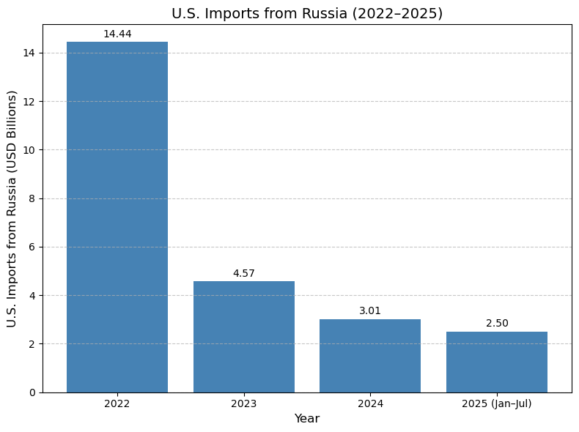

Figure 16— USA Imports From Russia (2022 -2025(Jan –July)

**Insights:**

The chart shows that **U.S. imports from Russia have steadily declined from 2022 to 2025**, but the reduction is not complete. The U.S. continues to import **critical resources** such **as fertilizers, uranium, and other nuclear materials**, highlighting the limits of sanctions when essential commodities remain in demand.

## ****Final Conclusion & Insights****

* From 2022–2025**, Russian oil trade shifted significantly toward Asia**, with India and China buying discounted Russian crude, helping stabilize global oil prices around $70 per barrel.
* Europe’s energy demand is increasingly met by U.S. exports.
* The U.S., through sanctions on Russia, exerts geopolitical pressure **while indirectly profiting** by supplying energy like oil, LNG, and gas to Europe.
* The **U.S. continues to trade with Russia** for essential supplies despite sanctions.
* **Ukraine importing Indian diesel** refined from Russian crude highlights how market pragmatism often outweighs geopolitical or moral considerations.
* The study highlights that fully blocking a nation’s trade is impractical; even the **EU** and **U.S**., **Russia’s** adversaries, continue to rely on imports from it for essential commodities.

## ****Future Trends (2025–2035)****

* **Europe’s Energy Dependence:** Europe’s reliance on U.S. and Middle Eastern energy supplies is expected to continue over the next 10 years, driven by diversification strategies and post-sanction adjustments.
* **India & China Imports from Russia:** Purchases of Russian oil by India and China are likely to remain steady rather than increase significantly, as both countries continue to maintain diversified supplier portfolios.
* **Russia as a Key Supplier:** Russia will continue to be a major energy supplier to Asia, especially if it offers discounted oil, with other Asian countries potentially increasing purchases influenced by India and China’s precedent.
* **Impact of Geopolitics:** If the Russia–Ukraine conflict ends, trade and supply patterns may normalize; however, geopolitical tensions and strategic energy decisions will continue to influence global oil flows.
* **Market Stability Outlook:** Despite potential normalization, shifts in oil and energy markets caused by geopolitical and economic factors are expected to persist for the next 5–10 years, maintaining volatility and strategic re-alignments.

**Prepared by: Mohit Chaturvedi**

**This report is based on publicly available data and analysis conducted by the author.**